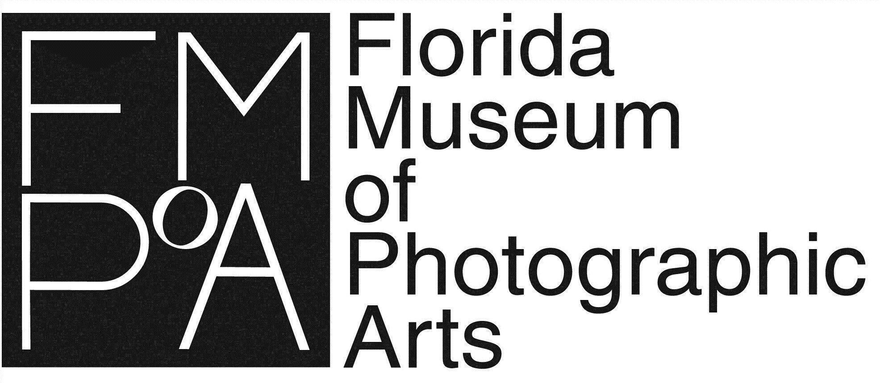

FOR IMMEDIATE RELEASE
CONTACTS: Lucas Campoe - Communications@fmopa.org; Leslie Farrell - Leslie@Farrellci.com, 813.493.1805

Florida Museum of Photographic Arts Begins Call For Entries for the 2024 International Photography Competition, Sponsored by Tampa International Airport and Visit Tampa Bay
Tampa, FL – The Florida Museum of Photographic Arts (FMoPA) is pleased to announce the beginning of the call for entries for the 2024 International Photography Competition, sponsored by Tampa International Airport (TPA) and Visit Tampa Bay (VTB). Now in its 13th year, this competition invites global photographers to submit their work for consideration in an exclusive exhibition at TPA. The call for entries is open from February 5 through May 5, 2024
The International Photography Competition, a longstanding tradition spanning over two decades, underscores FMoPA's commitment to elevating photographic art in daily life and culture. The competition beckons photographers worldwide to share their unique perspectives and artistic visions.
Following a record number of submissions in 2023 with over 2300 entries from 57 countries, FMoPA anticipates continued enthusiasm for the competition. Entries will undergo review by a distinguished international panel of judges, using evaluating criteria such as originality, technical excellence, composition, overall impact, and artistic merit. Three winners will be selected from each category, with an overall "Best In Competition" winner chosen from all submissions.
The categories for the 2024 International Photography Competition include:
- People/Portraits
- Places/Landscape
- Nature/Science/Animals
- Documentation/Photojournalism
- Still Life
- Conceptual
- Abstract Photography
Winners from each category will be featured in a group exhibition at TPA and receive prizes generously provided by VTB and other sponsors, including a $1000 prize for the Best in Competition.
Photographers interested in this competition can submit entries online through the FMoPA website (www.fmopa.org) starting February 5, 2024. The submission deadline is May 5, 2024.

About the Florida Museum of Photographic Arts
Florida Museum of Photographic Arts (FMoPA) is dedicated to exhibiting important photographic art as central to contemporary life and culture. FMoPA also enriches the community by operating outreach programs to educate children and adults. FMoPA is one of fewer than ten museums in the United States dedicated exclusively to photography and one of two such museums in Florida. In addition, the museum is home to high-impact community programs such as the Children's Literacy Through Photography program for at-risk children and adult photography classes, workshops, and children's summer camps. FMoPA’s move to historic Ybor City promises growth and a new and dynamic environment to showcase its extensive collection and host exhibitions from acclaimed photographers. More information is available at www.FMoPA.org and by calling (813)221-2222.

